Министерство образования Республики Беларусь

Учреждение образования «Белорусский государственный университет информатики и радиоэлектроники»

Факультет компьютерных систем и сетей

Кафедра информатики

Отчёт к лабораторной работе №3

Выполнил:

студент гр. 953501

Кондрашов И.Д.

Проверил:

Чащин C. В.

Минск 2022

# ИНИЦИАЛИЗАЦИЯ

DROP TABLESPACE tbs_1 INCLUDING CONTENTS AND DATAFILES; DROP USER prod CASCADE;

CREATE TABLESPACE tbs_1

DATAFILE 'tbs_1.dat' SIZE 10M

REUSE

AUTOEXTEND ON NEXT 10M MAXSIZE 200M; CREATE USER prod

IDENTIFIED BY 321 DEFAULT TABLESPACE tbs_1

QUOTA 200M on tbs_1; GRANT create session TO prod; GRANT create table TO prod; GRANT create view TO prod; GRANT create any trigger TO prod;

GRANT create any procedure TO prod; GRANT create sequence TO prod; GRANT create synonym TO prod;

--conn Prod;

CREATE TABLE prod.products

( product_id number(10) not null, product_name varchar2(50) not null, category varchar2(50),

CONSTRAINT products_pk PRIMARY KEY (product_id)

);

DROP TABLESPACE tbs_2 INCLUDING CONTENTS AND DATAFILES; DROP USER dev CASCADE;

CREATE TABLESPACE tbs_2

DATAFILE 'tbs_2.dat' SIZE 10M

REUSE

AUTOEXTEND ON NEXT 10M MAXSIZE 200M; CREATE USER dev

IDENTIFIED BY 321 DEFAULT TABLESPACE tbs_2

QUOTA 200M on tbs_2; GRANT create session TO dev; GRANT create table TO dev; GRANT create view TO dev; GRANT create any trigger TO dev;

GRANT create any procedure TO dev; GRANT create sequence TO dev; GRANT create synonym TO dev;

CREATE TABLE dev.products

( product_id number(10) not null, product_name varchar2(50) not null,

-- category varchar2(50),

CONSTRAINT products_pk PRIMARY KEY (product_id)

);

CREATE TABLE dev.qwer

( qwer_id number(10) not null, qwer_name varchar2(50) not null,

CONSTRAINT qwer_pk PRIMARY KEY (qwer_id)

);

SET SERVEROUTPUT ON;

# ЗАДАНИЕ 1.

Написать процедуру/функцию на вход которой подаются два текстовых параметра (dev_schema_name, prod_schema_name), которые являются названиями схем баз данных (условно схема для разработки(Dev) и промышленная схема(Prod)), на выход процедура должна предоставить перечень таблиц, которые есть в схеме Dev, но нет в Prod, либо в которых различается структура таблиц.

create or replace procedure COMPARE_SCHEMES(schema1 in varchar2, schema2 in varchar2) as

diff NUMBER := 0;

begin

## -- DIFFERENCE IN COLUMNS

dbms_output.put_line('Comparing 2 schemes, printing difference in tables');

FOR same_table IN (SELECT table_name FROM all_tables tables1 WHERE OWNER = schema1

## INTERSECT

SELECT tables2.table_name FROM all_tables tables2 WHERE OWNER = schema2) LOOP

SELECT COUNT(*) INTO diff FROM

(SELECT table1.COLUMN_NAME name,table1.DATA_TYPE FROM all_tab_columns table1 WHERE OWNER=schema1 AND TABLE_NAME= same_table.table_name) cols1

## FULL JOIN

(SELECT table2.COLUMN_NAME name,table2.DATA_TYPE FROM all_tab_columns table2 WHERE OWNER=schema2 AND TABLE_NAME = same_table.table_name) cols2

ON cols1.name = cols2.name

WHERE cols1.name IS NULL OR cols2.name IS NULL;

IF diff > 0 THEN

dbms_output.put_line('Table structure of ' || same_table.table_name || ' is different in ' || schema1 || ' and ' || schema2);

## ELSE

dbms_output.put_line('Table structure of ' || same_table.table_name || ' the same'); END IF;

## END LOOP;

end COMPARE_SCHEMES;

/

create or replace procedure COMPARE_SCHEMES_TABLES (

schema1 in varchar2

, schema2 in varchar2

) as begin

## -- DIFFERENCE IN TABLES

dbms_output.put_line('Comparing 2 schemes, printing difference in tables structures');

FOR other_table IN (SELECT tables1.table_name name FROM all_tables tables1 WHERE tables1.OWNER = schema1

## MINUS

SELECT tables2.table_name FROM all_tables tables2 WHERE tables2.OWNER=schema2) LOOP

dbms_output.put_line('Table ' || other_table.name || ' is in ' || schema1 || ' but not in ' || schema2);

## END LOOP;

FOR other_table IN (SELECT tables2.table_name name FROM all_tables tables2 WHERE tables2.OWNER=schema2

## MINUS

SELECT tables1.table_name FROM all_tables tables1 WHERE tables1.OWNER

= schema1) LOOP

dbms_output.put_line('Table ' || other_table.name || ' is in ' || schema2 || ' but not in ' || schema1);

## END LOOP;

end COMPARE_SCHEMES_TABLES;

DROP TABLE fk_tmp; CREATE TABLE fk_tmp(

id INT,

## CHILD_OBJ VARCHAR2(100), PARENT_OBJ VARCHAR2(100)

);

create or replace procedure SCHEME_TABLES_ORDER(schema_name in varchar2) as begin

## -- DIFFERENCE IN TABLES

EXECUTE IMMEDIATE 'TRUNCATE TABLE fk_tmp';

dbms_output.put_line('Showing tables order in schema');

FOR schema_table IN (SELECT tables1.table_name name FROM

all_tables tables1 WHERE OWNER = schema_name) LOOP

INSERT INTO fk_tmp (CHILD_OBJ, PARENT_OBJ)

SELECT DISTINCT a.table_name, c_pk.table_name r_table_name FROM all_cons_columns a

JOIN all_constraints c ON a.owner = c.owner AND a.constraint_name = c.constraint_name

JOIN all_constraints c_pk ON c.r_owner = c_pk.owner AND c.r_constraint_name = c_pk.constraint_name

WHERE c.constraint_type = 'R' AND a.table_name = schema_table.name;

## IF SQL%ROWCOUNT = 0 THEN

dbms_output.put_line( schema_table.name); END IF;

## END LOOP;

FOR fk_cur IN (

SELECT CHILD_OBJ,PARENT_obj,CONNECT_BY_ISCYCLE

FROM fk_tmp

CONNECT BY NOCYCLE PRIOR PARENT_OBJ = child_obj ORDER BY LEVEL

## ) LOOP

IF fk_cur.CONNECT_BY_ISCYCLE = 0 THEN

dbms_output.put_line(fk_cur.CHILD_OBJ); ELSE

dbms_output.put_line('CYCLE IN TABLE' || fk_cur.CHILD_OBJ); END IF;

## END LOOP;

end SCHEME_TABLES_ORDER;

begin

## COMPARE_SCHEMES('DEV', 'PROD'); COMPARE_SCHEMES_TABLES('DEV', 'PROD'); SCHEME_TABLES_ORDER('DEV'); SCHEME_TABLES_ORDER('PROD');

end;

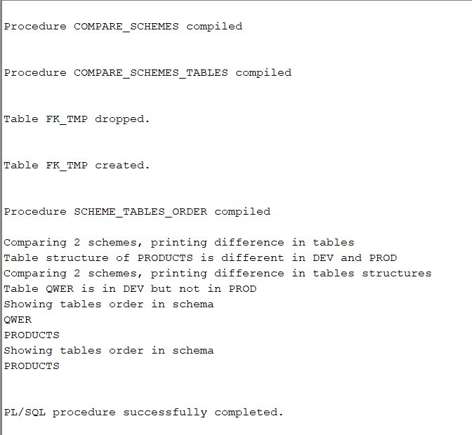

# ЗАДАНИЕ 2.

Доработать предыдущий скрипт с учетом возможности сравнения не только таблиц, но и процедур, функций, индексов пакетов.

## SELECT * FROM ALL_OBJECTS WHERE OBJECT_TYPE = 'TABLE' AND OWNER = 'DEV';

create or replace procedure COMPARE_SCHEMES_BY_OBJECT(schema1 in varchar2, schema2 in varchar2, object_type in varchar2)

as

diff NUMBER := 0;

begin

## -- DIFFERENCE IN COLUMNS

dbms_output.put_line('Comparing 2 schemes, printing difference in tables');

FOR obj_type IN ('PROCEDURE', 'PACKAGE', 'INDEX', 'TABLE') LOOP

FOR same_object IN (

SELECT objects1.object_name FROM ALL_OBJECTS objects1 WHERE OWNER = schema1 AND OBJECT_TYPE = obj_type

## INTERSECT

SELECT objects2.table_name FROM ALL_OBJECTS objects2 WHERE OWNER = schema2) AND OBJECT_TYPE = obj_type LOOP

SELECT COUNT(*) INTO diff FROM

(SELECT object1.OBJECT_NAME name, table1.DATA_TYPE FROM all_tab_columns table1 WHERE OWNER=schema1 AND TABLE_NAME= same_table.table_name) cols1

## FULL JOIN

(SELECT object2.OBJECT_NAME name, table2.DATA_TYPE FROM all_tab_columns table2 WHERE OWNER=schema2 AND TABLE_NAME = same_table.table_name) cols2

ON cols1.name = cols2.name

WHERE cols1.name IS NULL OR cols2.name IS NULL;

IF diff > 0 THEN

dbms_output.put_line('Table structure of ' || same_table.table_name || ' is different in ' || schema1 || ' and ' || schema2);

## ELSE

dbms_output.put_line('Table structure of ' || same_table.table_name || ' the same'); END IF;

## END LOOP;

END LOOP;

end COMPARE_SCHEMES;

create or replace procedure COMPARE_SCHEMES_TABLES (

schema1 in varchar2

, schema2 in varchar2

) as begin

## -- DIFFERENCE IN TABLES

dbms_output.put_line('Comparing 2 schemes, printing difference in tables structures');

FOR other_table IN (SELECT tables1.table_name name FROM all_tables tables1 WHERE tables1.OWNER = schema1

## MINUS

SELECT tables2.table_name FROM all_tables tables2 WHERE tables2.OWNER=schema2) LOOP

dbms_output.put_line('Table ' || other_table.name || ' is in ' || schema1 || ' but not in ' || schema2);

## END LOOP;

FOR other_table IN (SELECT tables2.table_name name FROM all_tables tables2 WHERE tables2.OWNER=schema2

## MINUS

SELECT tables1.table_name FROM all_tables tables1 WHERE tables1.OWNER

= schema1) LOOP

dbms_output.put_line('Table ' || other_table.name || ' is in ' || schema2 || ' but not in ' || schema1);

## END LOOP;

end COMPARE_SCHEMES_TABLES;

/

DROP TABLE fk_tmp; CREATE TABLE fk_tmp(

id INT,

## CHILD_OBJ VARCHAR2(100), PARENT_OBJ VARCHAR2(100)

);

create or replace procedure SCHEME_TABLES_ORDER(schema_name in varchar2) as

begin

## -- DIFFERENCE IN TABLES

EXECUTE IMMEDIATE 'TRUNCATE TABLE fk_tmp';

dbms_output.put_line('Showing tables order in schema');

FOR schema_table IN (SELECT tables1.table_name name FROM

all_tables tables1 WHERE OWNER = schema_name) LOOP

INSERT INTO fk_tmp (CHILD_OBJ, PARENT_OBJ)

SELECT DISTINCT a.table_name, c_pk.table_name r_table_name FROM all_cons_columns a

JOIN all_constraints c ON a.owner = c.owner AND a.constraint_name = c.constraint_name

JOIN all_constraints c_pk ON c.r_owner = c_pk.owner AND c.r_constraint_name = c_pk.constraint_name

WHERE c.constraint_type = 'R' AND a.table_name = schema_table.name;

## IF SQL%ROWCOUNT = 0 THEN

dbms_output.put_line( schema_table.name); END IF;

## END LOOP;

FOR fk_cur IN (

SELECT CHILD_OBJ,PARENT_obj,CONNECT_BY_ISCYCLE

FROM fk_tmp

CONNECT BY NOCYCLE PRIOR PARENT_OBJ = child_obj ORDER BY LEVEL

## ) LOOP

IF fk_cur.CONNECT_BY_ISCYCLE = 0 THEN

dbms_output.put_line(fk_cur.CHILD_OBJ); ELSE

dbms_output.put_line('CYCLE IN TABLE' || fk_cur.CHILD_OBJ);

## END IF; END LOOP;

end SCHEME_TABLES_ORDER;

begin

## COMPARE_SCHEMES('DEV', 'PROD'); COMPARE_SCHEMES_TABLES('DEV', 'PROD'); SCHEME_TABLES_ORDER('DEV'); SCHEME_TABLES_ORDER('PROD');

end;

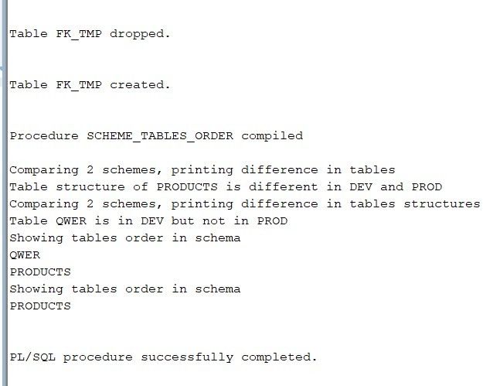

# ЗАДАНИЕ 3.

Доработать предыдущий скрипт с генерацией ddl-скрипта на обновление объектов, а также с учетом необходимости удаления в схеме prod объектов, отсутствующих в схеме dev.

## CREATE OR REPLACE PROCEDURE REPLACE_OBJECT (

schema1 IN VARCHAR2, schema2 IN VARCHAR2, object_type IN VARCHAR2, object_name IN VARCHAR2

## ) AS

query_string VARCHAR2(100); BEGIN

FOR src IN (SELECT line, text FROM ALL_SOURCE WHERE OWNER = schema1 AND NAME = object_name)

## LOOP

IF src.line =1 THEN

query_string := 'CREATE OR REPLACE ' || REPLACE(src.text, LOWER(object_name), schema2 || '.' || object_name);

## ELSE

query_string := query_string || src.text; END IF;

## END LOOP;

EXECUTE IMMEDIATE query_string; END REPLACE_OBJECT;

/

## CREATE OR REPLACE PROCEDURE CREATE_OBJECT (

schema1 IN VARCHAR2,

schema2 IN VARCHAR2, object_type IN VARCHAR2, object_name IN VARCHAR2

## ) AS

query_string VARCHAR2(100); BEGIN

FOR src IN (SELECT line, text FROM ALL_SOURCE WHERE OWNER = schema1 AND NAME = object_name)

## LOOP

IF src.line =1 THEN

query_string := 'CREATE ' || REPLACE(src.text, LOWER(object_name), schema2 || '.' || object_name);

## ELSE

query_string := query_string || src.text; END IF;

## END LOOP;

EXECUTE IMMEDIATE query_string; END CREATE_OBJECT;

/

## CREATE OR REPLACE PROCEDURE DELETE_OBJECT (

schema1 IN VARCHAR2, object_type IN VARCHAR2, object_name IN VARCHAR2

)

## AS

delete_query VARCHAR(100); BEGIN

delete_query := 'DROP ' || object_type || ' ' || schema1 || '.' || object_name; EXECUTE IMMEDIATE delete_query;

## END DELETE_OBJECT;

/

## CREATE OR REPLACE PROCEDURE COMPARE_OBJECTS (

schema1 IN VARCHAR2, schema2 IN VARCHAR2, object_type IN VARCHAR2

## ) AS

diff NUMBER :=0; BEGIN

FOR pair IN ( SELECT obj1.NAME AS name1, obj2.NAME AS name2 FROM

(SELECT OBJECT_NAME name FROM ALL_OBJECTS

WHERE OBJECT_TYPE = object_type AND OWNER = schema1) obj1 FULL JOIN

(SELECT OBJECT_NAME name FROM ALL_OBJECTS

WHERE OBJECT_TYPE = object_type AND OWNER = schema2) obj2 ON obj1.name = obj2.name ) LOOP

IF pair.name1 IS NULL THEN

DELETE_OBJECT(schema2,object_type, pair.name2); dbms_output.put_line('D');

ELSIF pair.name2 IS NULL THEN

CREATE_OBJECT(schema1, schema2, object_type, pair.name1); dbms_output.put_line('C');

## ELSE

SELECT COUNT(*) INTO diff FROM

all_source src1 FULL JOIN all_source src2 ON src1.name = src2.name

WHERE src1.name= pair.name1 AND src1.line = src2.line AND src1.text != src2.text

AND src1.OWNER = schema1 AND src2.OWNER = schema2;

IF diff > 0 THEN REPLACE_OBJECT(schema1,schema2,object_type,pair.name1); dbms_output.put_line('R');

END IF; END IF;

END LOOP;

END COMPARE_OBJECTS;

/

EXEC COMPARE_OBJECTS('DEV', 'PROD', 'PROCEDURE')